1) import java.util.\*;  
public class sanjay  
{  
  public static void main(String arr[])  
{  
  int n,a=1,b=0;  
  Scanner inp=new Scanner(System.in);  
  n=inp.nextInt();  
  for(int i=1;i<=n;i++)  
  {  
    for(int j=1;j<=i;j++)  
     {   if(j%2!=0)  
          {  
            System.out.print(a+" ");  
   }  
         else  
  {    
          System.out.print(b+" ");  
}  
       
     }  
      System.out.println();  
  }  
}  
  
}

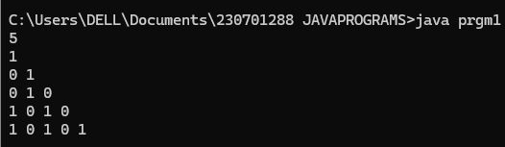

2)

import java.util.\*;

public class prgm1{

public static void main(String a[]){

Scanner sc= new Scanner(System.in);

int n=sc.nextInt();

for(int i=n;i>0;i--){

for(int j=1;j<=i;j++){

System.out.print(j+" ");

}

System.out.println();

}

}

}

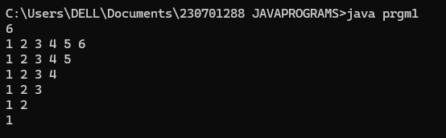

3) import java.util.\*;

public class prgm1{

public static void main(String a[]){

Scanner sc=new Scanner(System.in);

String day=sc.nextLine();

switch(day){

case("Sunday"):

case("Saturday"):

System.out.println("It's a weekend");

break;

case("Monday"):

case("Tuesday"):

case("Wednesday"):

case("Thrusday"):

case("Friday"):

System.out.println("It's a weekday");

break;

default:

System.out.println("invalid day");

break;

}

}

}

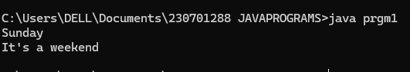

4)

import java.util.\*;

public class prgm1{

public static void main(String args[]){

Scanner obj=new Scanner(System.in);

System.out.println("enter the number");

int a=obj.nextInt();

int c=a;

int sum=0;

int rem;

int fact=1;

int i;

while(c!=0){

rem=c%10;

fact=1;

for(i=1;i<=rem;i++)

{

fact=fact\*i;}

c=c/10;

sum=sum+fact;

}

System.out.println(sum);

if(sum==a){

System.out.println("Strong");}

else{

System.out.println("Not Strong");}

}

}

